Surgery on Sunday Louisville Consulting

Use Case Specification: Setup An Alert System For Clinical Volunteer Database

Version 3.0

Revision History

|  |  |  |  |  |
| --- | --- | --- | --- | --- |
| **Date** | **Version** | **Description** | | **Author** |
| 21/Oct/17 | 1.0 | Setup Alert System For Clinical Volunteer Database | Cody Higdon | |
| 6/Nov/17 | 2.0 | Setup Alert System For Clinical Volunteer Database w/ Prototypes | | Cody Higdon |
| 7/Dec/17 | 3.0 | Setup Alert System For Clinical Volunteer Database w/ Prototypes | | Cody Higdon |
|  |  |  | |  |

Table of Contents

1. Use-Case Name 2

1.1 Brief Description 2

2. Flow of Events 4

2.1 Basic Flow 4

2.2 Alternative Flows 4

2.2.1 < First Alternative Flow > 4

2.2.2 < Second Alternative Flow > 4

3. Special Requirements 4

3.1 < First Special Requirement > 4

4. Pre-conditions 4

4.1 < Pre-condition One > 4

5. Post-conditions 4

5.1 < Post-condition One > 4

6. Extension Points 4

6.1 <Name of Extension Point> 4

7. Class Diagram 5

8. Sequence Diagram 6

9. Use Case Diagram 7

10. Prototype Diagram 8

10.1 <Prototype Description> 8

10.2 <Actual Prototype > 8

Use Case Specification: Setup an Alert System for Clinical Volunteer Database

# Setup an Alert System

## Brief Description

The purpose of this use case is to setup an alert system for clinical volunteer database. This is necessity to know when the clinic receives a new clinical volunteer. The alert system would allow Surgery on Sunday to see that a new clinical volunteer has entered their database.

# Flow of Events

## Basic Flow

* IT Coordinator creates alert settings on Clinical Volunteer Database

## Alternative Flows

### There are no alternative flows for this use case.

# Special Requirements

## The alert system must be able to alert any device that has access to the system. This will improve the knowledge of new volunteers that come into the Clinical database to help with future events. This will improve performance and knowledge of the employees creating events.

# Pre-conditions

## The IT Coordinator must have access to the organization’s system to set up the alert systems. The IT Coordinator logins into the system.

# Post-conditions

## The alert system for Clinical Volunteers will be created on Clinical Database. The IT Coordinator logs off the system. The Alert Systems will be received on their phone or computer that a new clinical volunteer has entered the database.

# Extension Points

## There are no extension points for this use case.

# Class Diagram

**IT Coordinator**

**Attributes:**

**-**Alert Settings

**Methods:**

+Create ()

# Sequence Diagram

IT Coordinator

**Object:**

Clinical Volunteer Database

**Class:**

Alert System



Creates



# Use Case Diagram:



# Prototype:

## 10.1 Prototype Description: This Prototype will be used to set up Alert System for Non-Clinical Volunteer Database. This will alert system will help notify SOSL of a new Non-Clinical Volunteer.

**10.2 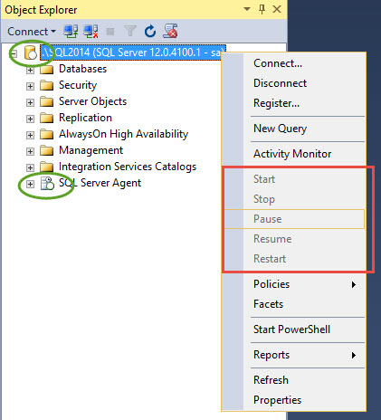Actual Prototype:**

Select Start & This will walk-through alert settings on this database